Project 2
Blackjack/21+Mini Game

Lucy Badescu
CIS-42375
June 1, 2018

Introduction

Title: Blackjack/21

Blackjack is a popular gambling game often played in casinos. Although the game is fairly simple, there are a few rules. Like the name suggests, the goal of the game is to score 21 points or to get as close to 21 as possible without going over. The moment you score over 21 you lose and if someone scores higher than you you also lose. The game starts with the player receiving two cards face up and the dealer receiving one card face up and the other face down. If the player’s first two cards make 21 (Blackjack), the dealer reveals its second card and if it is also a 21 you tie, otherwise you win. If the dealer’s first card is a 10 or 11, the dealer reveals its second card and if it’s a 21 you lose.
If none of these things occur, the game proceeds as normal and the dealer asks if you wish to “stand” or “hit.” This choice is up to you. If you choose “Hit” the dealer will give you cards, one at a time so that you can attempt to get closer to 21. They will stop once you tell them to or if you go over 21. If you go over 21 then it’s a “Bust” and you lose immediately. If your first two cards are close enough to 21 where it becomes to risky to ask for more, you can choose to “Stand” and thus to not get any more cards. Once you do, the dealer will play their hand and reveal their second card. If both cards add up to a score under 16, then the dealer is forced to take more cards until he has at least a score of 17 unless they go over 21 first. If the dealer has at least 17 points, then they do not take any more cards. If no player goes over 21 and no one scores an actual 21, then the player closest to 21 wins.

Summary

Project length: The game itself has 530 lines but with the mini game and the Functions at the end it adds up to 703.
Number of variables: 20 Blackjack + 9 Mini Game – Total 29
Number of constants: 3 Blackjack + 1 Mini Game – Total 4
Function Prototypes: 7 Blackjack + 2 Mini Game – Total 9

Like last time, the project took about a week to complete.
In revising my program I realized that there were a few instances in which the program failed to mark a tie and instead marked a loss. This time around, I was able to go back into this and make sure it properly marked a tie, victory, or loss. This time around by using functions, I was able to make the program less cluttered allowing me to be able to add input validation to the program. However, in order to do this, I changed the input entered by the user from characters to integers. Now instead of entering y(yes), h(hit), s(stand), or n(no), the user must enter numbers from 1 to 4 to play the game, 4 being used to quit the game. (Warning: do not enter any characters as input, the program will crash. I do not know how to prevent the user from entering characters). Ironically, even though the program became much shorter with the addition of Functions, because I had to go back and add the missing “ties,” the program ended up becoming a bit longer.

The elements that I had left out from the original game last time (splitting of hands and betting on the dealer), I decided to leave out this time around as well because I did not consider them to be necessary for the game. The point system that I used in the last game (2 to 11) also remains.

Addition of the Mini Game:
Because I did not have a way of successfully adding any arrays or searching and sorting elements to the game of blackjack, I added a mini game with these elements at the end. The game starts automatically after exiting the game of blackjack. One the user reaches the end of the Mini Game they have the option to exit the program entirely by entering -1 or repeat the mini game by entering 1.

Because of the way the blackjack program determines wins and loses, and because of the way the player points and the program points are matched, I was not able to successfully add arrays to the program itself. It became too confusing to match the player points to the program points for comparison and I could not find a way to make the program add one card at the time. Because of this, the mini game was added to show that I do know how to utilize arrays as well as sorting/searching.

Blackjack Flowchart (top half)
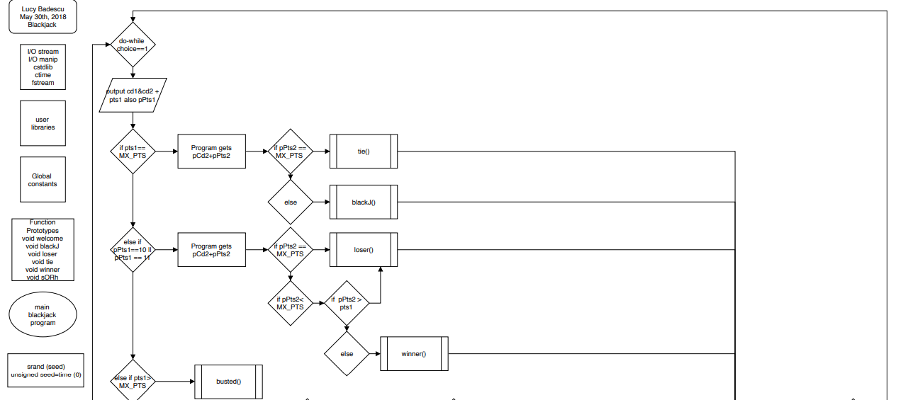

BlackJack Flowchart (Bottom Half)
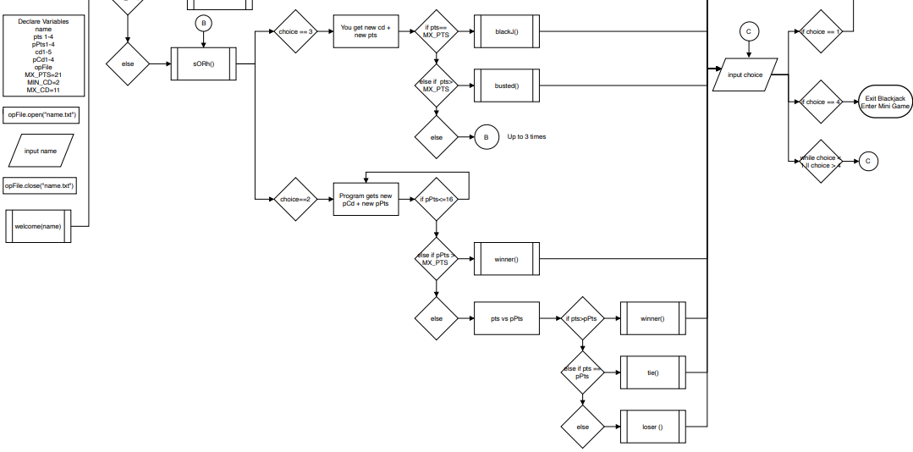
Constructs and Concepts Utilized

NAME | FREQUENCY | DESCRIPTION | LINE
Static_cast | 1 |  | 80
Cout | 98 |  | Throughout
cin | 56 |  | Throughou
Getline() | 1 | To get name | 68
Srand() | 1 | For rand | 64
Rand() | 17 | To generate random numbers | First: 75  Last: 435
Seed=time(0) | 1 | w/ ctime library | 61
Setw() | 29 | For spacing | Fist: 81  Last: 438
string | 3 | For name, input[], hNum, lNum | 38, 49, 53
ofstream | 1 | For opFile (“name.txt”) | 43
ifstream | 6 | In Functions: blackJ, winner, loser, tie, busted, rules | 609 to 671
Function Prototypes | 9 | Welcome, blackJ, winner, loser, tie, busted, rules, sORh, search | Called Throughout  Declared 22-31
Arrays | 3 | For MiniGame | 47
If |  |  | Throughout First: 108
If/else |  |  | Throughout First: 90/95
If/else if |  |  | Throughout First: 101
Nested if |  |  | First: 113
switch | 3 | 2 cases (2/3) | 136, 159, 180
bool | 1 | Function: search | 539, 550, 558
for | 3 |  | Last 568
while | 2 | On line 521 for input validation | First: 521  Last: 693
Do-while | 2 | For blackjack and mini game | BJ: 72/530  MG: 536/590
Int | 9 |  | 37-55
const | 4 |  | 46, 58/60
libraries | 5 | Iostream, iomanip, cstdlb, ctime & fstream | 9-13

References

Textbook: Tony Gaddis, “Starting Out with C++” - 8th edition.
bicyclecards.com - https://www.bicyclecards.com/how-to-play/blackjack/#filter=.casino //Used as reference to see the rules for blackjack.

Code:
/*
* File: main.cpp
* Author: Lucy Badescu
* Created on May 30th, 2018, 8:55 PM
* Purpose: Blackjack/21 (Project 2/Modified)
*/

//System Libraries
#include <iostream> //I/O Library -> cout,endl
#include <iomanip> //Format Library
#include <cstdlib> //Rand/Srand
#include <ctime> //Time
#include <fstream> //File i/o
using namespace std;//namespace I/O stream library created

//User Libraries

//Global Constants
//Math, Physics, Science, Conversions, 2-D Array Columns

//Function Prototypes
void welcome(string);
void blackJ ();
void loser ();
void tie ();
void busted ();
void winner ();
void sORh ();
//used for mini game
void rules();
int search(const int[], int, int);

//Execution Begins Here!

int main() {
//Declare Variables
int choice;//character entered by player
string name;//player name
int pts1, pts2, pts3, pts4,//to hold the points accumulated by player
pPts1, pPts2, pPts3, pPts4,//to hold the program's score
cd1, cd2, cd3, cd4, cd5,//to hold the player card values
pCd1, pCd2, pCd3, pCd4;//to hold the program card values
ofstream opFile;//output file
//Variables used in Mini Game
int play;//to hold y or n
const int NUMB=5;
int youN[NUMB];
int val;//to hold value entered by user
string input[NUMB]={"Number 1", "Number 2", "Number 3", "Number 4",
"Number 5"};
int progN[NUMB] = {55, 23, 89, 10, 99};
int hgst, lowst;//to hold highest and lowest number
string hNum, lNum;//to hold name of highest and lowest number
int avgTot;//to hold average for total
int result;

//Initial Variables
const int MX_PTS=21;//to hold max score
const int MIN_CD=2;//to hold minimum card points
const int MX_CD=11;//to hold max card points
unsigned seed=time(0);

//Map/Process Inputs to Outputs
srand(seed);
//Display Outputs
opFile.open("name.txt");
cout<<"Welcome to Blackjack on C++, please enter your name: ";
getline(cin,name);
opFile<<name<<endl;
opFile.close();
welcome(name);
do{
cout<<endl;
cout<<"You will receive two cards and the program will receive one\n";
cd1=(rand()%(MX_CD-MIN_CD+1))+MIN_CD;
cd2=(rand()%(MX_CD-MIN_CD+1))+MIN_CD;
pCd1=(rand()%(MX_CD-MIN_CD+1))+MIN_CD;
pts1=cd1+cd2;
pPts1=pCd1;
pPts1=static_cast<float>(pCd1);
cout<<"Your Cards: "<<cd1<<setw(5)<<cd2<<" ";
cout<<"Points: "<<pts1<<endl;
cout<<"Program Cards: "<<pPts1<<endl;
if (pts1==MX_PTS)
{
cout<<"The program will reveal it's second card.\n";
pCd2=(rand()%(MX_CD-MIN_CD+1))+MIN_CD;
pPts2=pCd1+pCd2;
cout<<"The program has: "<<pPts2<<endl;
if (pPts2==MX_PTS)
{
tie ();
cin>>choice;
}
else
{
blackJ ();
cin>>choice;
}
}
else if (pPts1==10 || pPts1==11)
{
cout<<"The program will reveal it's second card.\n";
pCd2=(rand()%(MX_CD-MIN_CD+1))+MIN_CD;
pPts2=pCd1+pCd2;
cout<<"Program Cards: "<<pCd1<<setw(3)<<pCd2<<endl;
cout<<"Points: "<<pPts2<<endl;
if (pPts2==MX_PTS)
{
loser ();
cin>>choice;
}
if (pPts2<MX_PTS)
{
if (pPts2>pts1)
{
loser ();
cin>>choice;
}
else
{
winner ();
cin>>choice;
}
}
}
else if (pts1>MX_PTS)
{
busted();
cin>>choice;
}
else
{
sORh();
cin>>choice;
switch (choice){
case 3:{
cout<<"1.The program will give you another card.\n";
cd3=(rand()%(MX_CD-MIN_CD+1))+MIN_CD;
pts2=cd1+cd2+cd3;
cout<<"Your Cards: "<<cd1<<setw(3)<<cd2<<setw(3)<<cd3<<endl;
cout<<"Points: "<<pts2<<endl;
cout<<"Program Cards: "<<pCd1<<endl;
cout<<"Points: "<<pPts1<<endl;
if(pts2==MX_PTS)
{
blackJ ();
cin>>choice;
}
else if (pts2>MX_PTS)
{
busted ();
cin>>choice;
}
else
{
sORh();
cin>>choice;
switch (choice){
case 3:{
cd4=(rand()%(MX_CD-MIN_CD+1))+MIN_CD;
pts3=cd1+cd2+cd3+cd4;
cout<<"2.Player Cards: "<<cd1<<setw(3);
cout<<cd2<<setw(3)<<cd3<<setw(3)<<cd4<<endl;
cout<<"Points: "<<pts3<<endl;
if(pts3==MX_PTS)
{
blackJ ();
cin>>choice;
}
else if (pts3>MX_PTS)
{
busted ();
cin>>choice;
}
else
{
sORh();
cin>>choice;
switch (choice){
case 3:{
cd5=(rand()%(MX_CD-MIN_CD+1))+MIN_CD;
pts4=cd1+cd2+cd3+cd4+cd5;
cout<<"3.Player Cards: "<<cd1;
cout<<setw(3)<<cd2<<setw(3)<<cd3;
cout<<setw(3)<<cd4<<setw(3)<<cd5<<endl;
cout<<"Points: "<<pts4<<endl;
if(pts4==MX_PTS)
{
blackJ ();
cin>>choice;
}
else if (pts4>MX_PTS)
{
busted ();
cin>>choice;
}
}
case 2:{
cout<<"3.The program receives another";
cout<<" card.\n";
pCd2=(rand()%(MX_CD-MIN_CD+1))+MIN_CD;
pPts2=pCd1+pCd2;
cout<<"Program cards: "<<pCd1<<setw(3);
cout<<pCd2<<endl;
cout<<"Points: "<<pPts2<<endl;
if (pPts2<=16)
{
cout<<"3A.The program receives";
cout<<" another card.\n";
pCd3=(rand()%(MX_CD-MIN_CD+1))+MIN_CD;
pPts3=pCd1+pCd2+pCd3;
cout<<"Program cards: "<<pCd1<<setw(3);
cout<<pCd2<<setw(3)<<pCd3<<endl;
cout<<"Points: "<<pPts3<<endl;
if(pPts3<=16)
{
cout<<"3B.The program receives";
cout<<" another card.\n";
pCd4=(rand()%(MX_CD-MIN_CD+1))+MIN_CD;
pPts4=pCd1+pCd2+pCd3+pCd4;
cout<<"Program cards: "<<pCd1;
cout<<setw(3)<<pCd2<<setw(3);
cout<<pCd3<<setw(3)<<pCd4<<endl;
cout<<"Points: "<<pPts4<<endl;
if(pPts4>MX_PTS)
{
winner ();
cin>>choice;
}
else
{
cout<<"Player Points: ";
cout<<pts4<<endl;
cout<<"Program Points: ";
cout<<pPts4<<endl;
if (pts4>pPts4)
{
winner();
cin>>choice;
}
else if (pts4==pPts4)
{
tie();
cin>>choice;
}
else
{
loser();
cin>>choice;
}
}
}
else if (pPts3>MX_PTS)
{
winner();
cin>>choice;
}
else
{
cout<<"Player points: ";
cout<<pts3<<endl;
cout<<"Program Points: ";
cout<<pPts3<<endl;
if (pts3>pPts3)
{
winner();
cin>>choice;
}
else if (pts3==pPts3)
{
tie();
cin>>choice;
}
else
{
loser();
cin>>choice;
}
}
}
else if (pPts2>MX_PTS)
{
winner();
cin>>choice;
}
else
{
cout<<"Player points: "<<pts3<<endl;
cout<<"Program Points: "<<pPts2<<endl;
if (pts3>pPts2)
{
winner();
cin>>choice;
}
else if (pts3==pPts2)
{
tie();
cin>>choice;
}
else
{
loser();
cin>>choice;
}
}
}
break;
}
break;
}
break;
}
case 2:{
cout<<"2.The program receives another card.\n";
pCd2=(rand()%(MX_CD-MIN_CD+1))+MIN_CD;
pPts2=pCd1+pCd2;
cout<<"Program cards: "<<pCd1<<setw(3)<<pCd2<<endl;
cout<<"Points: "<<pPts2<<endl;
if (pPts2<=16)
{
cout<<"2A.The program receives another card.\n";
pCd3=(rand()%(MX_CD-MIN_CD+1))+MIN_CD;
pPts3=pCd1+pCd2+pCd3;
cout<<"Program cards: "<<pCd1<<setw(3)<<pCd2;
cout<<setw(3)<<pCd3<<endl;
cout<<"Points: "<<pPts3<<endl;
if(pPts3<=16)
{
cout<<"2B.The program receives another card.\n";
pCd4=(rand()%(MX_CD-MIN_CD+1))+MIN_CD;
pPts4=pCd1+pCd2+pCd3+pCd4;
cout<<"Program cards: "<<pCd1<<setw(3)<<pCd2;
cout<<setw(3)<<pCd3<<setw(3)<<pCd4<<endl;
cout<<"Points: "<<pPts4<<endl;
if(pPts4>MX_PTS)
{
winner();
cin>>choice;
}
else
{
cout<<"Program Points: "<<pPts4<<endl;
cout<<"Player Points: "<<pts2<<endl;
if (pts2>pPts4)
{
winner();
cin>>choice;
}
else if (pts2==pPts4)
{
tie();
cin>>choice;
}
else
{
loser();
cin>>choice;
}
}
}
else if (pPts3>MX_PTS)
{
winner();
cin>>choice;
}
else
{
cout<<"Player points: "<<pts2<<endl;
cout<<"Program Points: "<<pPts3<<endl;
if (pts2>pPts3)
{
winner();
cin>>choice;
}
else if (pts2==pPts3)
{
tie();
cin>>choice;
}
else
{
loser();
cin>>choice;
}
}
}
else if (pPts2>MX_PTS)
{
winner();
cin>>choice;
}
else
{
cout<<"Player points: "<<pts2<<endl;
cout<<"Program Points: "<<pPts2<<endl;
if (pts2>pPts2)
{
winner();
cin>>choice;
}
else if(pts2==pPts2)
{
tie();
cin>>choice;
}
else
{
loser();
cin>>choice;
}
}
}
break;
}
}
}break;
case 2:{
cout<<"1.The program receives another card.\n";
pCd2=(rand()%(MX_CD-MIN_CD+1))+MIN_CD;
pPts2=pCd1+pCd2;
cout<<"Program cards: "<<pCd1<<setw(3)<<pCd2<<endl;
cout<<"Points: "<<pPts2<<endl;
if (pPts2<=16)
{
cout<<"1A.The program receives another card.\n";
pCd3=(rand()%(MX_CD-MIN_CD+1))+MIN_CD;
pPts3=pCd1+pCd2+pCd3;
cout<<"Program cards: "<<pCd1<<setw(3)<<pCd2<<setw(3);
cout<<pCd3<<endl;
cout<<"Points: "<<pPts3<<endl;
if(pPts3<=16)
{
cout<<"1B.The program receives another card.\n";
pCd4=(rand()%(MX_CD-MIN_CD+1))+MIN_CD;
pPts4=pCd1+pCd2+pCd3+pCd4;
cout<<"Program cards: "<<pCd1<<setw(3)<<pCd2<<setw(3);
cout<<pCd3<<setw(3)<<pCd4<<endl;
cout<<"Points: "<<pPts4<<endl;
if(pPts4>MX_PTS)
{
winner();
cin>>choice;
}
else
{
cout<<"Program Points: "<<pPts4<<endl;
cout<<"Player Points: "<<pts1<<endl;
if (pts1>pPts4)
{
winner();
cin>>choice;
}
else if (pts1==pPts4)
{
tie();
cin>>choice;
}
else
{
loser();
cin>>choice;
}
}
}
else if (pPts3>MX_PTS)
{
winner();
cin>>choice;
}
else
{
cout<<"Player points: "<<pts1<<endl;
cout<<"Program Points: "<<pPts3<<endl;
if (pts1>pPts3)
{
winner();
cin>>choice;
}
else if (pts1==pPts3)
{
tie();
cin>>choice;
}
else
{
loser();
cin>>choice;
}
}
}
else if (pPts2>MX_PTS)
{
winner();
cin>>choice;
}
else
{
cout<<"Player points: "<<pts1<<endl;
cout<<"Program Points: "<<pPts2<<endl;
if (pts1>pPts2)
{
winner();
cin>>choice;
}
else if (pts1==pPts2)
{
tie();
cin>>choice;
}
else
{
loser();
cin>>choice;
}
}
}
break;
}
}
while (choice<1||choice>4)
{
cout<<"Please enter a valid choice (1-4): ";
cin>>choice;
}
if (choice==4)
{
cout<<"Thank you for playing! Please come back again."<<endl;
}
}while (choice==1);
//end of blackjack
//bonus mini game
cout<<endl;
cout<<"BONUS Mini Game!";
rules();
do{
int num;
cout<<"Enter 5 different numbers.\n";
for (int count=0; count<NUMB;count++)
{
cout<<input[count]<<": ";
cin>>youN[count];
while (youN[count]<0)
{
cout<<"Please enter a positive value: ";
cin>>youN[count];
}
}
int tot=0;
for (int count = 0; count<NUMB;count++)
{
tot+=youN[count];
}
cout<<"The total of your numbers added is: "<<tot<<endl;
avgTot=tot/NUMB;
cout<<"The average is: "<<avgTot<<endl;
hgst=youN[0];
for (int count=1;count<NUMB;count++)
{
if (youN[count] > hgst)
{
hNum =input[count];
hgst = youN[count];
}
}
cout<<"The largest number is: "<<hNum<<endl;
lowst=youN[0];
for (int count=1;count<NUMB;count++)
{
if (youN[count] < lowst)
{
lNum=input[count];
lowst = youN[count];
}
}
cout<<"The lowest number is: "<<lNum<<endl;
cout<<endl;
result=search(progN, NUMB, val);
if (result==-1)
cout<<"Not a match.\n";
else
cout<<"Match!\n";
cout<<"Play again? (1=yes -1=no): ";
cin>>play;
if (play==-1)
{
cout<<"Thank you for playing!"<<endl;
}

}while (play==1);

//Exit program!
return 0;
}
void welcome(string name)
{
cout<<endl;
cout<<"Hello "<<name<<" I will give you a quick overview of the game.\n";
cout<<"The purpose of the game is to get as close to 21 as possible. \n";
cout<<"It will be you against the program. Because we do not have picture\n";
cout<<"cards, the program will generate random numbers from 2 to 11. \n";
cout<<"If at anytime you wish to stop playing, you may Quit the game\n";
cout<<"by entering 4. Good luck! \n";
}
void blackJ ()
{
string name;
char choice;
ifstream inFile;//input file
inFile.open("name.txt");

inFile>>name;
cout<<"BLACKJACK! Congratulations "<<name<<" you have won!\n";
cout<<"Would you like to try again? (1=yes/4=quit): ";
inFile.close();
}
void loser ()
{
string name;
char choice;
ifstream inFile;//input file
inFile.open("name.txt");

inFile>>name;
cout<<"Sorry "<<name<<", the program wins. Try again? (1=yes/4=quit): ";
inFile.close();
}
void tie ()
{
string name;
char choice;
ifstream inFile;//input file
inFile.open("name.txt");

inFile>>name;
cout<<name<<" you have tied, try again?(1=yes/4=quit): ";
inFile.close();

}
void busted ()
{
string name;
char choice;
ifstream inFile;//input file
inFile.open("name.txt");

inFile>>name;
cout<<"BUSTED! "<<name<<", you lose.\n";
cout<<"Would you like to play again? (1=yes/4=quit): ";
inFile.close();
}
void winner ()
{
string name;
char choice;
ifstream inFile;//input file
inFile.open("name.txt");

inFile>>name;
cout<<"Congratulations "<<name<<", you have won!\n";
cout<<"Would you like to play again? (1=yes/4=quit): ";
inFile.close();
}
void sORh ()
{
cout<<"Would you like to Stand(2) or Hit(3)?: ";
}
void rules ()
{
string name;
ifstream inFile;//input file
inFile.open("name.txt");

inFile>>name;
cout<<endl;
cout<<"We will now play a simple numbers game. You will enter 5 numbers\n";
cout<<"and I will give you the average, their total, the smallest and \n";
cout<<"largest of your numbers. You will then enter another number to see \n";
cout<<"if it matches one of 5 numbers in our data base. (Hint: if you \n";
cout<<"want to try to make a match, enter values between 1-100). Alright \n";
cout<<name<<" we will now begin."<<endl;
cout<<endl;
inFile.close();
}
int search(const int progN[], int NUMB, int val)
{
int index = 0;
int pos=-1;
bool found=false;

cout<<"Enter a number between 1-100: ";
cin>>val;
while (index<NUMB && !found)
{
if (progN[index]==val)
{
found=true;
pos=index;
}
index++;
}
return pos;
}

